

Practices for Secure Software Report

Table of Contents
Document Revision History 3
Client 3
Instructions 3
Developer 4
1. Algorithm Cipher 4
2. Certificate Generation 4
3. Deploy Cipher 4
4. Secure Communications 4
5. Secondary Testing 4
6. Functional Testing 4
7. Summary 4
8. Industry Standard Best Practices 4

Document Revision History

Version | Date | Author | Comments
1.0 | 06/07/2026 | Benjamin Holcomb

Client



Instructions

Submit this completed practices for secure software report. Replace the bracketed text with the relevant information. You must document your process for writing secure communications and refactoring code that complies with software security testing protocols.

- Respond to the steps outlined below and include your findings.
- Respond using your own words. You may also choose to include images or supporting materials. If you include them, make certain to insert them in all the relevant locations in the document.
- Refer to the Project Two Guidelines and Rubric for more detailed instructions about each section of the template.

Developer
Benjamin Holcomb

Algorithm Cipher

For secure communications between the client and server, the application was refactored to use HTTPS (TLS) to protect data in transit and support secure server authentication. In addition, a data verification step was added using a cryptographic hash to produce a checksum for a unique data string, and then verify that checksum by recomputing the hash and comparing the result. This ensures that if the transmitted/processed data is altered, the checksum verification fails, providing integrity protection.
The checksum mechanism uses SHA-256, which outputs a 256-bit digest. Unlike encryption, hashing does not rely on symmetric or asymmetric keys for verification—correctness depends on hashing the same input bytes in a consistent encoding. Random numbers are not required for SHA-256 checksum verification unless a nonce/salt is explicitly added, while TLS uses a combination of asymmetric cryptography (for certificate-based authentication and key establishment) and symmetric cryptography (for efficient bulk encryption). Overall, the refactor replaces insecure or weak integrity approaches with modern, industry-accepted cryptographic primitives and documents how integrity and secure transport are enforced in the application.

Certificate Generation
Insert a screenshot below of the CER file.

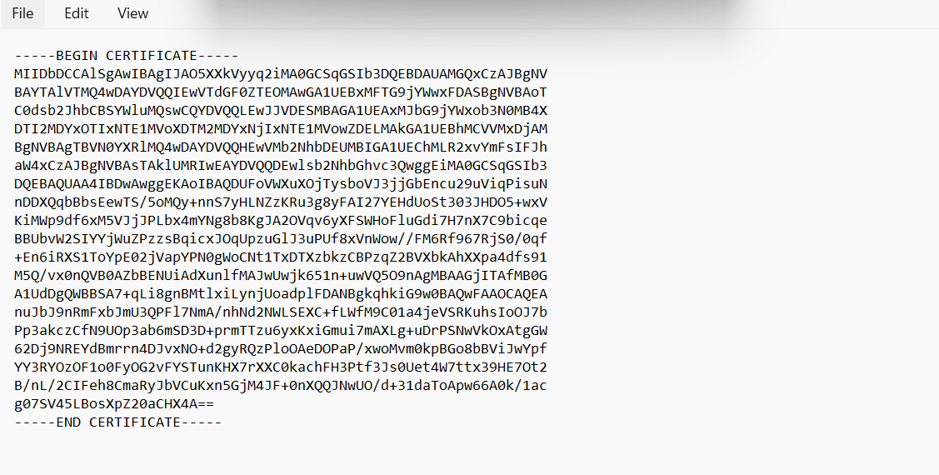

Deploy Cipher
Insert a screenshot below of the checksum verification.

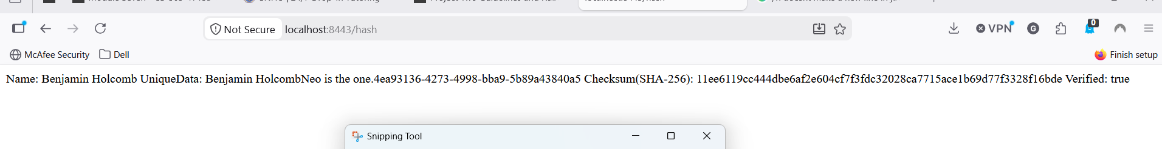

Secure Communications
Insert a screenshot below of the web browser that shows a secure webpage.

Secondary Testing
Insert screenshots below of the refactored code executed without errors and the dependency-check report.

[INFO]
[INFO] [1m--- [0;32minstall:2.5.2:install[m [1m(default-install)[m @ [36mssl-server[0;1m ---[m
[INFO] Installing C:\Users\gtrhe\eclipse-workspace\CS 305 Project Two Code Base.zip_expanded\ssl-server_student\target\ssl-server-0.0.1-SNAPSHOT.jar to C:\Users\gtrhe\.m2\repository\com\snhu\ssl-server\0.0.1-SNAPSHOT\ssl-server-0.0.1-SNAPSHOT.jar
[INFO] Installing C:\Users\gtrhe\eclipse-workspace\CS 305 Project Two Code Base.zip_expanded\ssl-server_student\pom.xml to C:\Users\gtrhe\.m2\repository\com\snhu\ssl-server\0.0.1-SNAPSHOT\ssl-server-0.0.1-SNAPSHOT.pom
[INFO] [1m------------------------------------------------------------------------[m
[INFO] [1;32mBUILD SUCCESS[m
[INFO] [1m------------------------------------------------------------------------[m
[INFO] Total time: 18.215 s
[INFO] Finished at: 2026-06-21T00:27:35-04:00
[INFO] [1m------------------------------------------------------------------------

Functional Testing
Insert a screenshot below of the refactored code executed without errors.

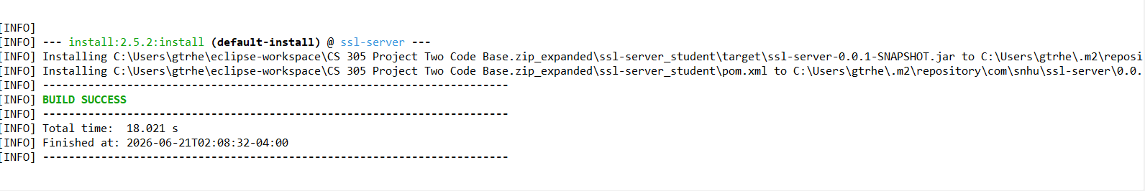

Summary

After refactoring the Spring Boot /hash flow to use a checksum verification step, I performed functional testing by compiling and running the application to confirm there were no syntax or runtime errors, then I verified the endpoint logic by submitting a known data string along with its correct checksum and confirming the application returns a successful verification result. Next, I repeated the test using the same data string with an intentionally modified checksum (or the data modified while keeping the checksum the same) to confirm the endpoint correctly rejects tampered or corrupted inputs. I also tested basic edge cases supported by the endpoint to ensure the application fails safely and returns an appropriate error response rather than crashing. Finally, I reviewed that the checksum verification logic uses the intended secure hashing approach (SHA-256) and that the comparison/verification behavior is consistent and does not expose sensitive values in logs or responses, and I captured the required screenshot showing the refactored code executed without errors while demonstrating the verification outcome.

Industry Standard Best Practices

Overall, the Spring Boot code was refactored by adding a secure integrity verification mechanism to the /hash processing path so that data transferred through the application is validated via checksum verification before being trusted or acted upon. This refactor directly supports security testing protocols by pairing the code change with functional validation (confirming correct behavior for both valid and invalid checksums), and with static verification using dependency-check to reduce the risk of introducing vulnerable third-party components through the changes made for checksum and related security improvements. The layered security approach used in this refactor applies multiple defenses: transport security through HTTPS for protection during communication, and integrity protection through a cryptographic checksum (e.g., SHA-256) to detect corruption or tampering, thereby helping prevent attackers from injecting altered payloads without detection. Industry-standard secure coding best practices were followed by selecting a modern, non-deprecated hashing algorithm, ensuring invalid verification results are handled in a fail-closed way (reject rather than accept), limiting refactoring scope to only the necessary security-relevant areas to preserve the application’s existing behavior, and structuring the code so that checksum generation and verification are deterministic, testable, and appropriate for the Spring Boot request flow.

